2013 Sponsorship Contract

Contact Information
“I have never given a dime away. I have only made investments in worthwhile charitable institutions.”
Charles A. Dana, Founder
The Dana Foundation
Company
Company Representative _____________________________
Telephone Fax

Sponsorship Package
( ) National Sponsor $5000

With this package, you are entitled to all of the following benefits. Some companies do not wish to have all of them for one reason or another. Please check all that you would like to be provided with.
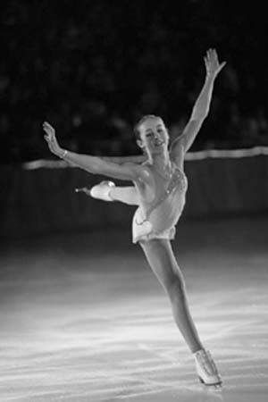
( ) 17 tickets: # for Saturday show ____, # for Sunday show ____
Photo courtesy of Yeang Ch’ng 2005

( ) 17 reception invites: # for Saturday show ____ , # for Sunday show ____
( ) 5 invitations to EWC Gala
( ) Full page ad in Commemorative program
( ) EWC Commemorative Gift Package
( ) Publicity in Boston-area and Harvard campus posters and publications
( ) Product exposure through the Silent Auction/Skater gift bag (if checked, please indicate in the comment section the product that will be provided)
( ) Mention on the appreciation poster displayed in the Bright Hockey Center during the show
( ) Mention in newspaper and radio PSAs, as well as on corporate sponsors board by merchandise stands
( ) Opportunity to promote company at a table outside the arena
( ) Company name and logo in the general program
( ) Opportunity to hang a company-provided banner on boards around the ice
( ) DVD advertisement

Special Requests or Comments:

______________________ _______________________
Address all correspondence to:
Barbara Basil and Jenny Le
Sponsorship Chair

An Evening with Champions
533 Eliot Mail Center
Cambridge, MA 02138
Office Phone: (617) 493-8172
Fax: (617) 495-8820
Donor Executive Board Member
______________________ _______________________
Signature Signature
______________________ _______________________
Date Date

